NST21022 - Practical for Network Switching and Routing
Department of Information and Communication Technology
Faculty of Technology
Lab sheet :10
Reg. Number: SEU/IS/20/ICT/084
Academic Year :2020/2021
Practical No :10

Title: IPv6 and IPv6 Subnetting
Aim:
IPv6 Subnetting Scheme
Configure IPv6 Subnetting

Task:
• Subnet the IPv6 address
• Assign IPv6 address to Network devices and verify connectivity

Use “NST21022 Labsheet 10.pka” file Activities

Exercise 01: Subnet the 2001:db8:1::/48 network into the appropriate subnets.

- Discuss about link local address.

- Based on the topology, how many subnets were needed?

- 8 subnets

Exercise 02: Fill the subnet table.
Subnet Number | Network Address | First Usable Host Address
A | 2001:db8:1:1:/64 | 2001:db8:1:1:0:0:0:1
B | 2001:db8:1:2:/64 | 2001:db8:1:2:0:0:0:1
C | 2001:db8:1:3:/64 | 2001:db8:1:3:0:0:0:1
D | 2001:db8:1:4:/64 | 2001:db8:1:4:0:0:0:1
E | 2001:db8:1:5:/64 | 2001:db8:1:5:0:0:0:1
F | 2001:db8:1:6:/64 | 2001:db8:1:6:0:0:0:1
G | 2001:db8:1:7:/64 | 2001:db8:1:7:0:0:0:1
H | 2001:db8:1:8:/64 | 2001:db8:1:8:0:0:0:1

Exercise 03: Configure IPv6 address according to following criteria.
1. Fill the addressing table using following guidelines:
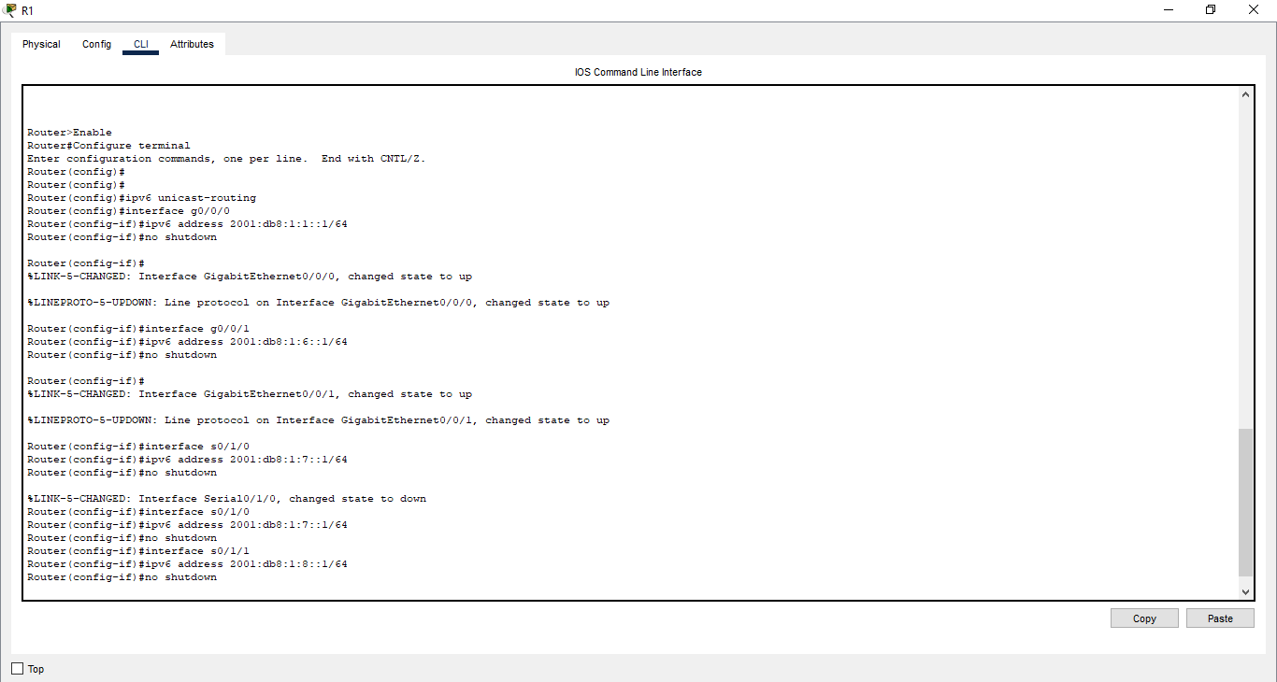
a. Assign the first usable IPv6 addresses in each subnet to R1, R2, R3 for the LAN links and R1’s WAN links.

b. Assign the second usable IPv6 addresses in subnet for the WAN links R2 and R3.
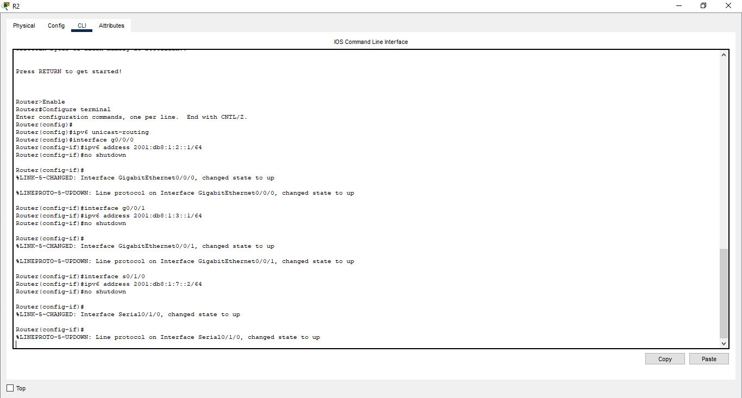

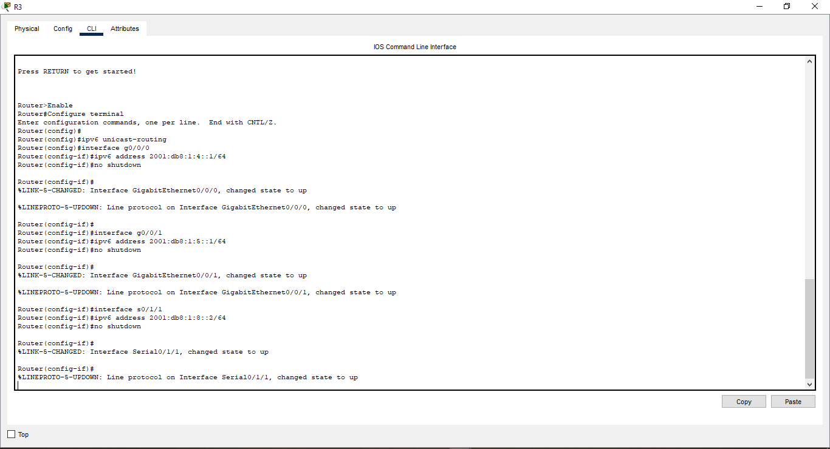

c. Assign the second usable IPv6 address to the PCs in each subnet

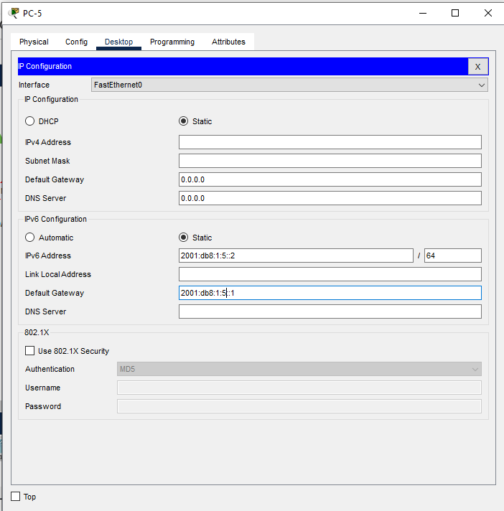
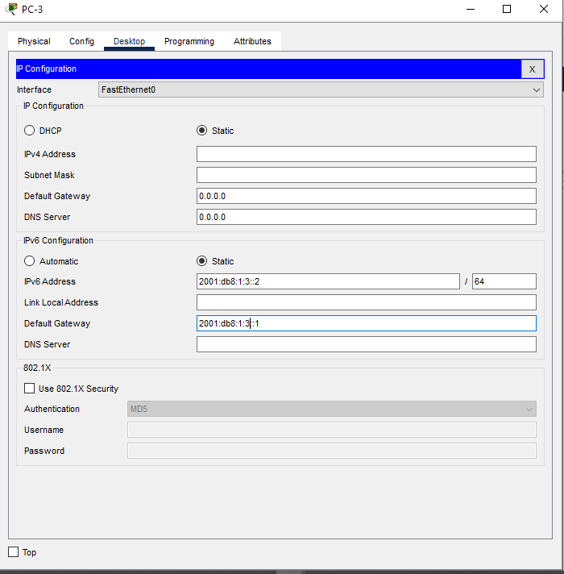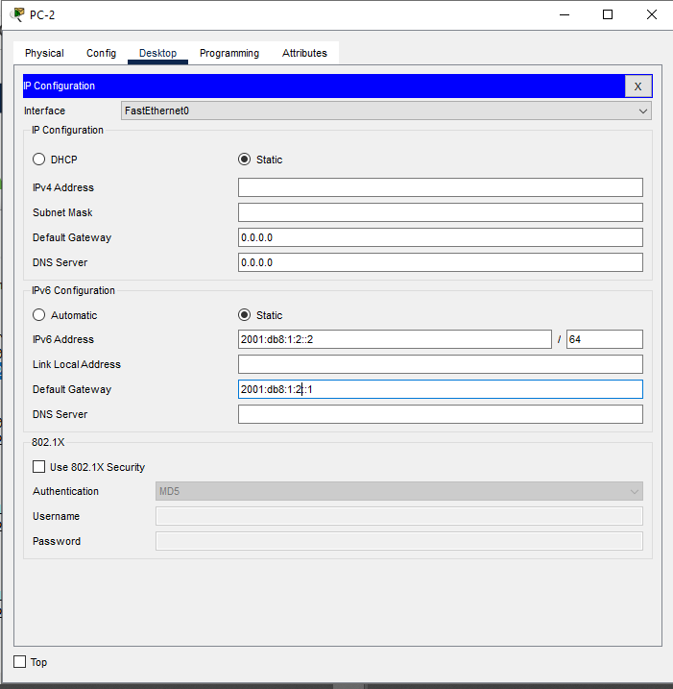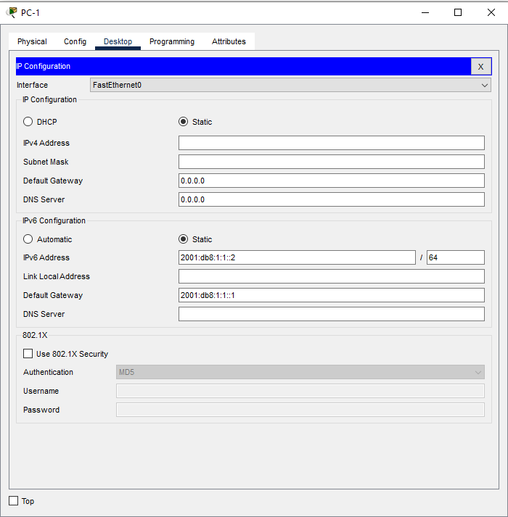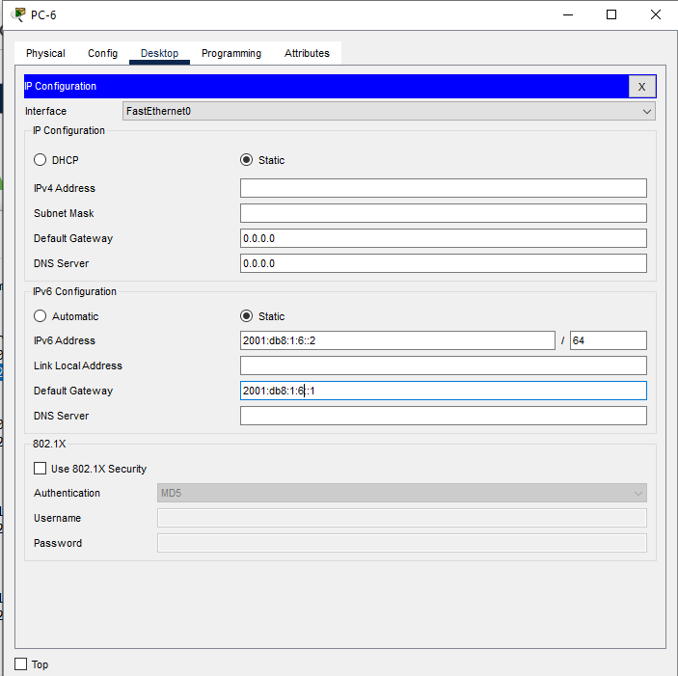

Addressing Table
Devices | Interfaces | IPv6 Addresses/Prefix | Default Gateway
R1 |  | 2001:db8:1:1:0:0:0:1/64
  G0/0/0
R1 |  | 2001:db8:1:6:0:0:0:1/64
  G0/0/1
R1 |  | 2001:db8:1:7:0:0:0:1/64
  S0/1/0
R1 |  | 2001:db8:1:8:0:0:0:1/64
  S0/1/1
R2 |  | 2001:db8:1:2:0:0:0:1/64
  G0/0/0
R2 |  | 2001:db8:1:3:0:0:0:1/64
  G0/0/1
R2 |  | 2001:db8:1:7:0:0:0:2/64
  S0/1/0
R3 |  | 2001:db8:1:4:0:0:0:1/64
  G0/0/0
R3 |  | 2001:db8:1:5:0:0:0:1/64
  G0/0/1
R3 |  | 2001:db8:1:7:0:0:0:2/64
  S0/1/0
PC-1 | NIC | 2001:db8:1::1:0:0:2/64 | 2001:db8:1:1:0:0:0:1
PC-2 | NIC | 2001:db8:1:6:0:0:0:2/64 | 2001:db8:1:6:0:0:0:1
PC-3 | NIC | 2001:db8:1::2:0:0:2/64 | 2001:db8:1:2:0:0:0:1
PC-4 | NIC | 2001:db8:1:3:0:0:0:2/64 | 2001:db8:1:3:0:0:0:1
PC-5 | NIC | 2001:db8:1:4:0:0:0:2/64 | 2001:db8:1:4:0:0:0:1
PC-6 | NIC | 2001:db8:1:5:0:0:0:2/64 | 2001:db8:1:5:0:0:0:1

- Assign IPv6 addresses to network devices and verify connectivity
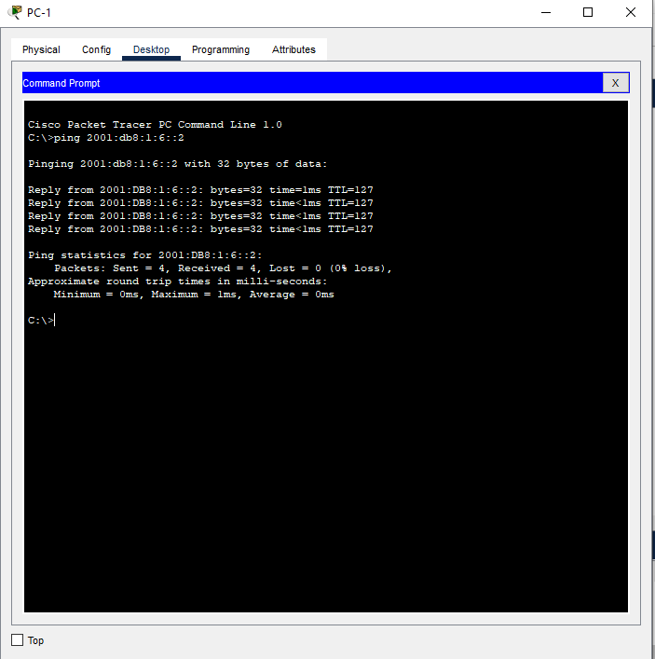

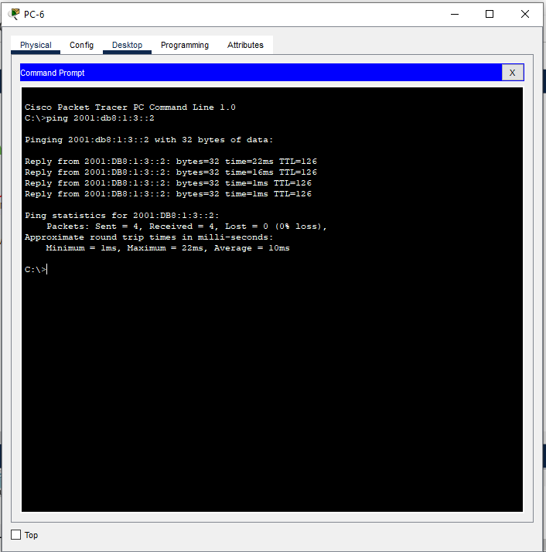

Discussion
- In this lab session, we focused on IPv6 subnetting and configuring IPv6 addresses on network devices. The main objective was to create an efficient IPv6 subnetting scheme. We began by subnetting the IPv6 address, dividing the network into smaller, manageable subnets based on the given requirements. After designing the subnets, we assigned IPv6 addresses to network devices such as routers, switches, and hosts. Finally, we verified the connectivity by testing communication between the devices within the same subnet and across different subnets. This session provided valuable hands-on experience in configuring and managing IPv6 networks, ensuring seamless communication across devices.

